**Java Installation**

Before installation, check if java is installed in your machine or not?

* Go to windows terminal cmd or powershell and run the command
* java -version to check the version of Java installed.
  + Java -version

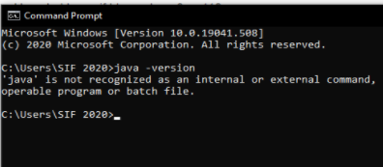

**Step1** : Install Java SDK

* Download and install java Java software development kit (JDK) from -> <https://www.oracle.com/java/technologies/javase/javase-jdk8-downloads.html>

Note: This JDK version comes bundled with Java Runtime Environment (JRE), so you do not need to download and install the JRE separately.

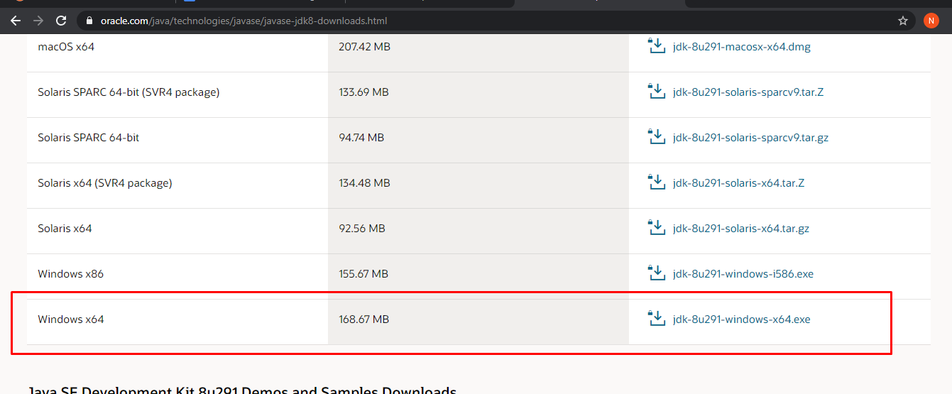

Go ahead, accept the license agreement and download the file.

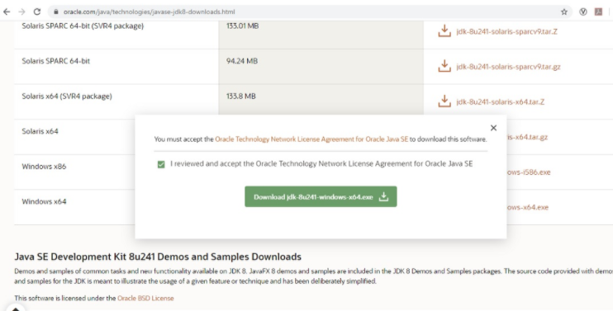

You will be asked to login to start the download. If you don’t have an Oracle account, you can create one here.

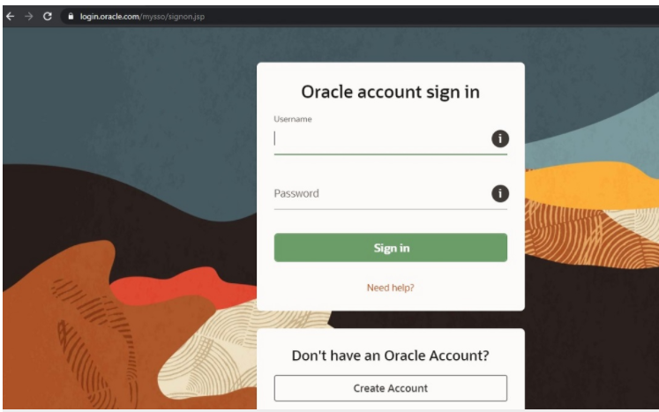**Step 2-** Run the Installer : To start the installation process, run the installer by double clicking it. You will see the installation wizard.

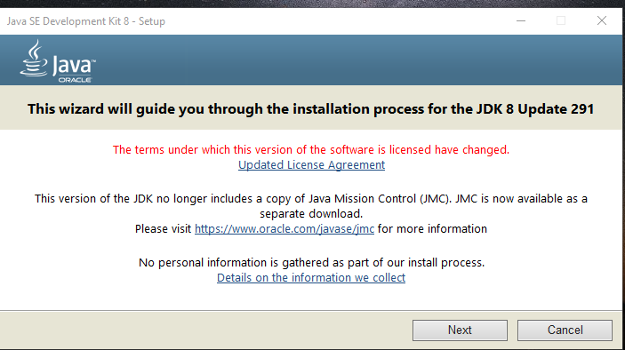

**Step 3-** Custom Setup : In this screen you can change certain installation defaults. I accept this as it is. You can change the installation directory if you want by clicking on change. Click next to continue.

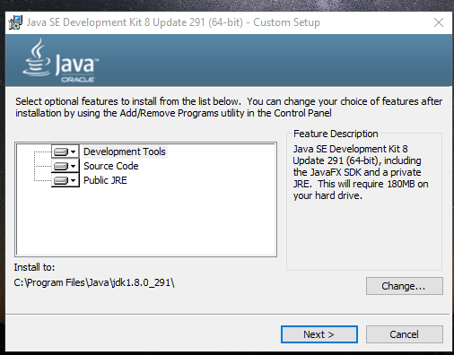

**Step4:** Installation begins:

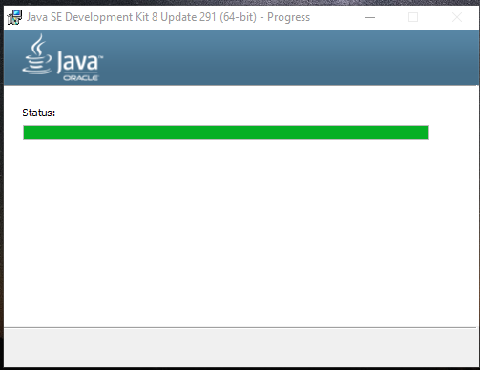

You will be asked to specify the default installation folder for JRE. I accept the default and click next.

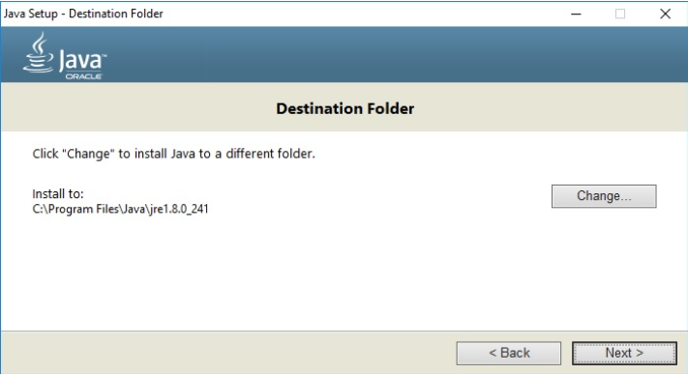

Once the installation completes, you will see the Installation complete message -> Click on close to complete the installation.

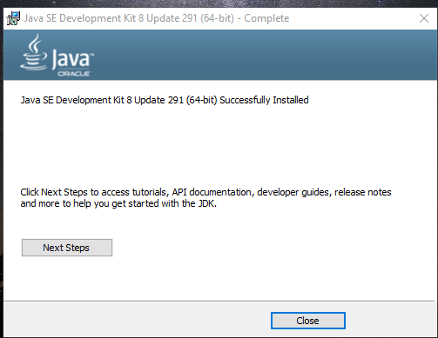

Step 5- Check the version of Java installed

* Go to windows terminal cmd or powershell and run the command
* java -version to check the version of Java installed.

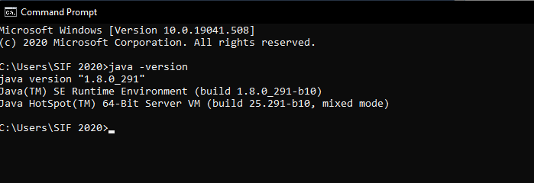

That’s it, now you have Java JDK installed on your system.

**Installation of Eclipse IDE**

-Before installation of Eclipse : Check System configuration

The installation depends on the OS’s type. Basically we have 2-system-type i.e. 64-bit and 32-bit OS.

For eg; If we have a 32-bit OS, we need to install a 32-bit Eclipse IDE else 64-bit Eclipse IDE.

* Check your system configuration:
  + Go to the Control panel -> System & security -> System

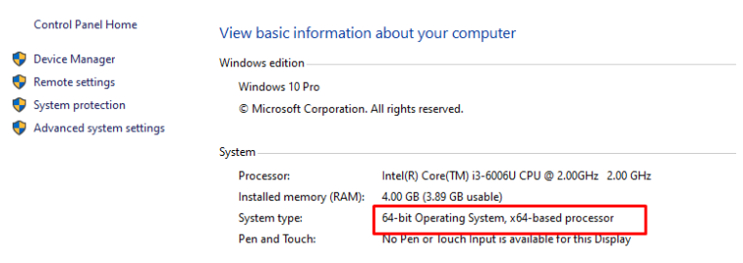

**Step1**: Download latest version of "Eclipse IDE-> <http://www.eclipse.org/downloads/>

Note: Be sure to choose correctly between Windows 32 Bit and 64 Bit versions.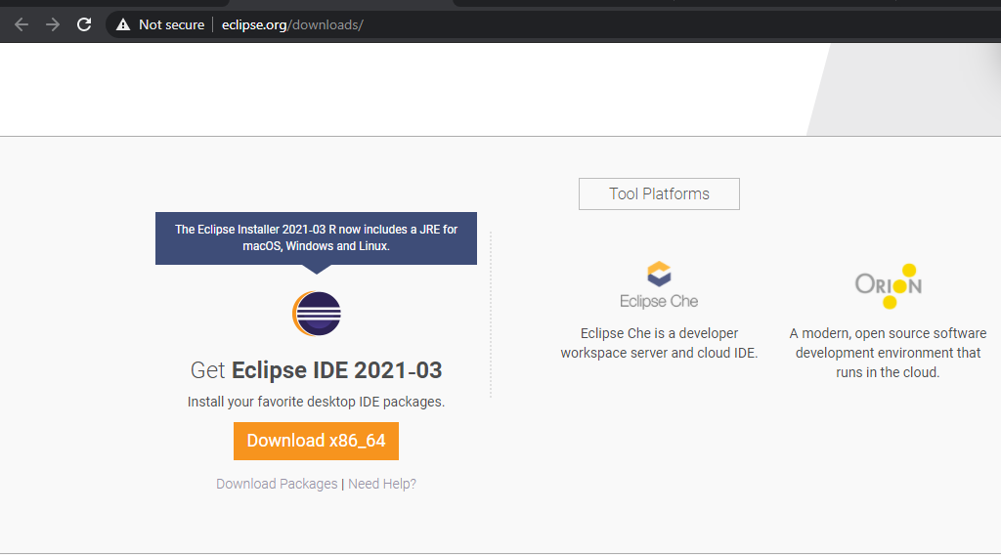

**Step2:** Double-click on file to Install the Eclipse. A new window will open.

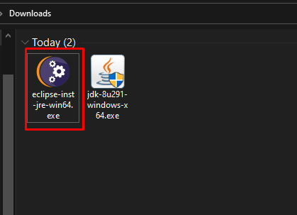

**Step 3**: Click Eclipse IDE for Java Developers.

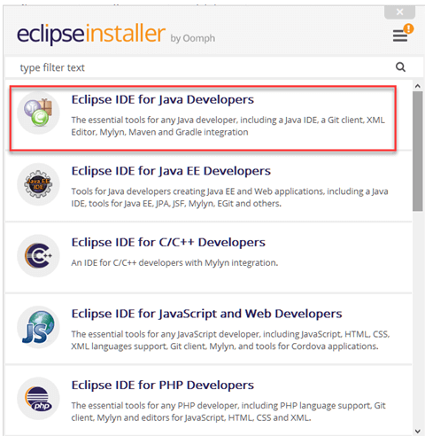

**Step4 :** Select JRE14.0.2 from the list.

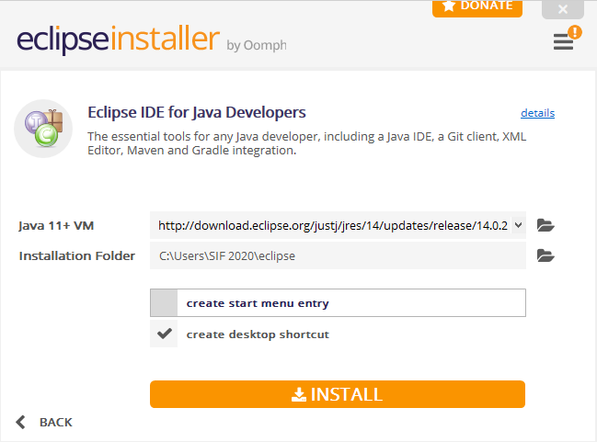

**Accept the license**.

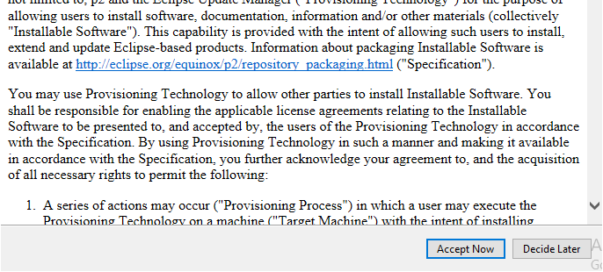

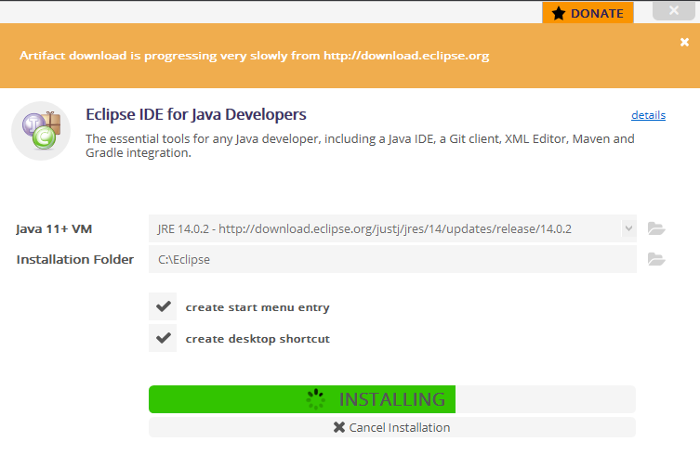

Select the eclipse workspace and click on Next

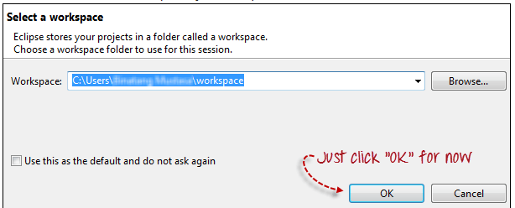

**Installation of Gradle**

**Step1:** Before installation of gradle, check the jdk version. We have already installed the Java JDK version 8

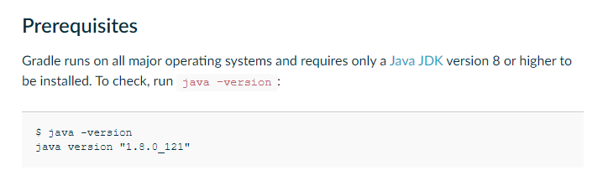

**Step2:** Download the latest gradle distribution <https://gradle.org/install/> -OR - <https://gradle.org/next-steps/?version=7.0.2&format=bin>

**Step3:** Unpack the distribution.

* For Windows user:
* Create a new directory C:\Gradle with File Explorer.
* Open a second File Explorer window and go to the directory where the Gradle distribution was downloaded. Double-click the ZIP archive to expose the content. Drag the content folder gradle-7.0.2 to your newly created C:\Gradle folder.

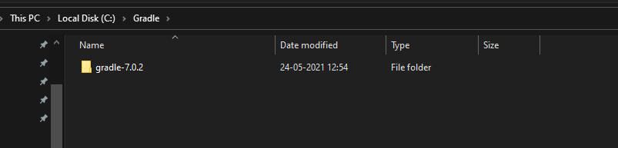

#### **Step 4.** Configure your system environment

* Fow windows user:
* In File Explorer right-click on the This PC (or Computer) icon, then click Properties -> Advanced System Settings -> Environment Variables.

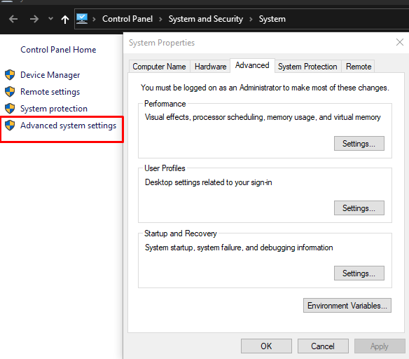

* Under System Variables select Path, then click Edit. Add an entry for C:\Gradle\gradle-7.0.2\bin. Click OK to save.

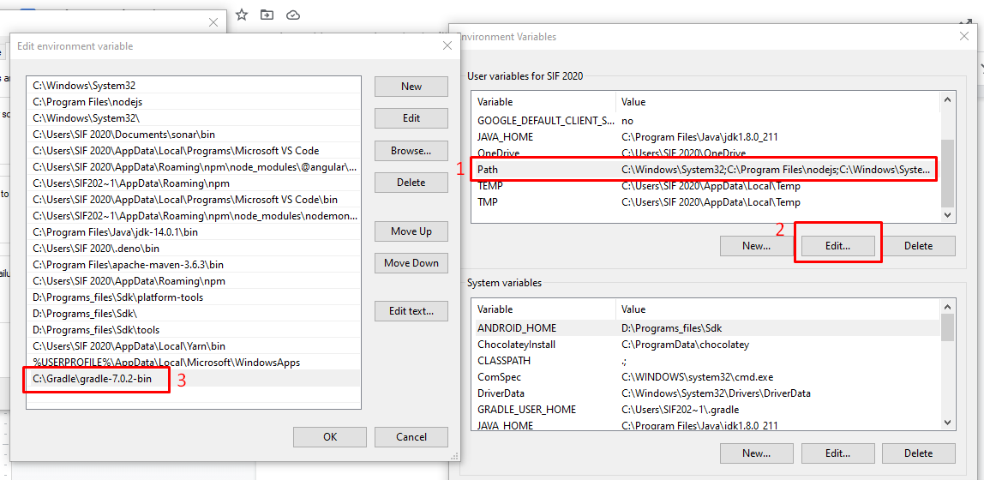

#### **Step 5**. Verify your installation -> Open a console (or a Windows command prompt) and run gradle -v to run gradle and display the version, e.g.:

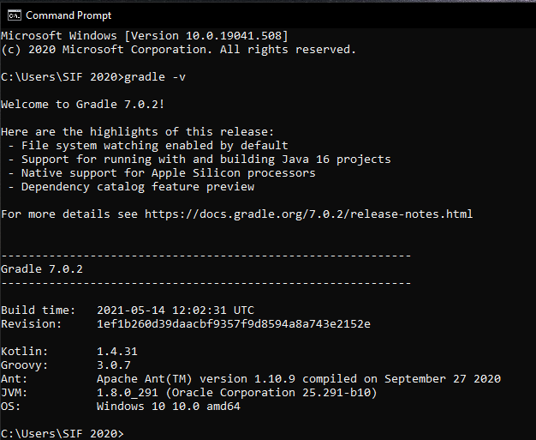

**Import gradle-project**

**Step1:** Open Eclipse IDE

**Step2**: Select the workspace & Launch

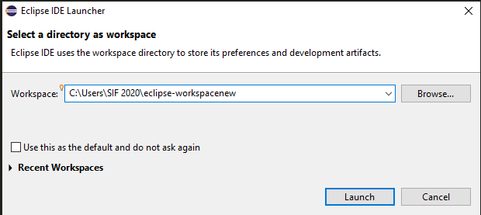

**Step3**: Click on ‘Import Projects’

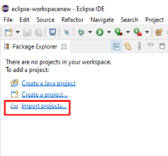

**Step4:** Select the ‘Gradle Project’ and Click Next

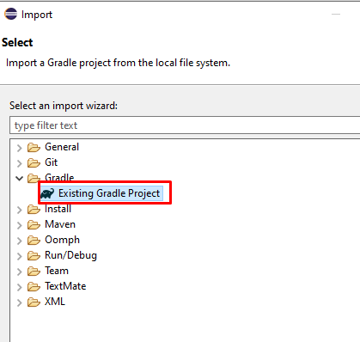

**Step 5:** Click Next

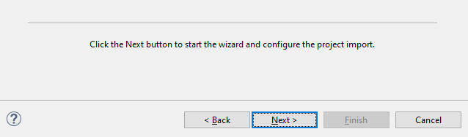

**Step6**: Select Project folder and click on ‘Finish’ button.

One the project is successfully imported and no issues are seen then we can run this project.

Before running this project,we need to install testng from Eclipse marketplace. **See below steps for“Installation for TestNG”.**

**Installation for TestNG**

1. Eclipse IDE -> Click on Help -> Select ‘Eclipse Marketplace’.
2. Search for ‘TestNG’ in search box and click on ‘Install’ button

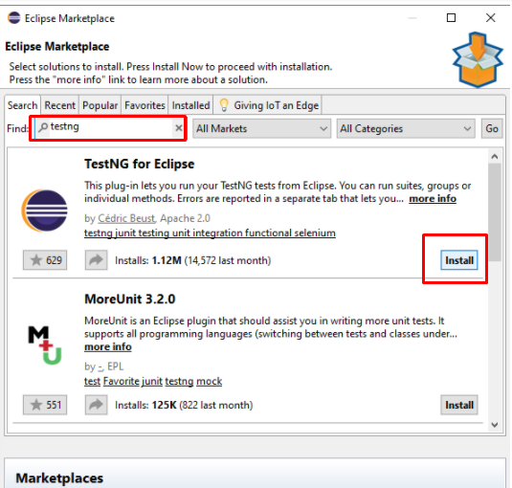

1. Once it is installed -> Close the Eclipse IDE and Reopen it.

To run the automation scripts.

* Go to the file system …… efa-web-automation-20210207T124345Z-001\efa-web-automation
* Type cmd on the and Go to the command prompt run the below commands.
* **First command:**     gradle cleanEclipse
* **Second command:**    gradlew clean testExec -Dcucumber.options="--tags @user" -Dbrowser=chrome

**First command:**     gradle cleanEclipse

**Second command:**    gradlew clean testExec -Dcucumber.options="--tags @user" -Dbrowser=chrome

